**“TESLA CLONE”**

**PROJECT REPORT**

**WEB DESIGNING**

**BACHELOR OF TECHNOLOGY**

**IN**

**COMPUTER SCIENCE ENGINEERING**

**DELHI TECHNOLOGICAL UNIVERSITY**

(Formerly Delhi College of Engineering)

Bawana Road, Delhi – 110042

Submitted by: Under the supervision of:

Aniket Kumar Ankit Kandulna Mr./Ms…………………..

(23/CS/051) (23/CS/060)

(BATCH: CSE-1,1st SEMESTER)

**CANDIDATE’S DECLARATION**

We, ANKIT KANDULNA 23/CS/060 and ANIKET KUMAR 23/CS/051 student of B. TECH (Computer Science) hereby declare that the Innovative Project Report titled **“TESLA CLONE”** which is submitted by me to Department of Computer Science, Delhi Technological University, Delhi, is original and not copied from any source without proper citation. This work has not previously formed the basis for the award of any Degree, Diploma, Fellowship or other similar title or recognition.

Place- DTU, Delhi

ANKIT KANDULNA ANIKET KUMAR

(23/CS/060) (23/CS/051)

**CERTIFICATE**

We ANKIT KANDULNA 23/CS/060 and ANIKET KUMAR 23/CS/051 hereby certify that the Project titled **“TESLA CLONE”** which is submitted By ANKIT KANDULNA 23/CS/060 and ANIKET KUMAR 23/CS/051 Department of Computer Science, Delhi Technological University, Delhi, as part of Innovative Work is a record of project work carried out by the student under my supervision. To the best of my knowledge, this work has not been submitted in part or full for any Degree or Diploma to this University or elsewhere.

Place- DTU, Delhi Mr./Ms…………………..

Date:

**ACKNOWLEDGEMENT**

We are very thankful to Ms. SHREYA SHUKLA (Research Scholar, Computer Science, DTU) and all the faculty members of the Computer Science Dept. of DTU. They all provided immense support and guidance for the completion of the project undertaken by me. It is with their supervision that this work came into existence.

We would also like to express my gratitude to the university for providing the laboratories, infrastructure, test facilities and environment which allowed us to work without any obstructions.

We would also like to appreciate the support provided by our seniors and peer group who aided us with all the knowledge they had regarding various topics.

ANKIT KANDULNA ANIKET KUMAR

(23/CS/060) (23/CS/051)

**ABSTRACT**

The aim of this project is to show a demo that how Car companies make website using HTML and CSS. Our clone shows how interactive a website can be. It have very good GUI which helps in attracting customers. We can redirect the link to original website for more functions.

**TABLE OF CONTENT**

Candidate Declaration ……………………….(ii)

Certificate ……………………….(iii)

Acknowledgement ……………………….(iv)

Abstract ……………………….(v)

1. Introduction …………………………7
2. Working and Functionality …………………………8
3. Utilities and Technologies used …………………………9
4. Future scope and conclusion …………………………9-10

**INTRODUCTION**

Nowadays, most of us prefer to see Car Online Before buying and we also check thousand of reviews before buying it and we contact our relatives for help in buying the car. In this project we have a created a website which helps in buying any car model of Tesla Company and we added new functions solar roof and solar panels so that if any needed them then will be provided.

Our website show the design of the car to help to see the differences in model of our cars.

There are various features available on the home page like VEHICLES, ENERGY, CHARGING, DISCOVER, SHOP, CUSTOMER SUPPORT, REGION, SHOP which help the website to use it efficiently.

We created the website using HTML, CSS. This project is very helpful for students aspiring to build a Car Company.

**WORKING AND FUNCTIONALITIES USED**

**Working Of Project:**

This is interface of our website.

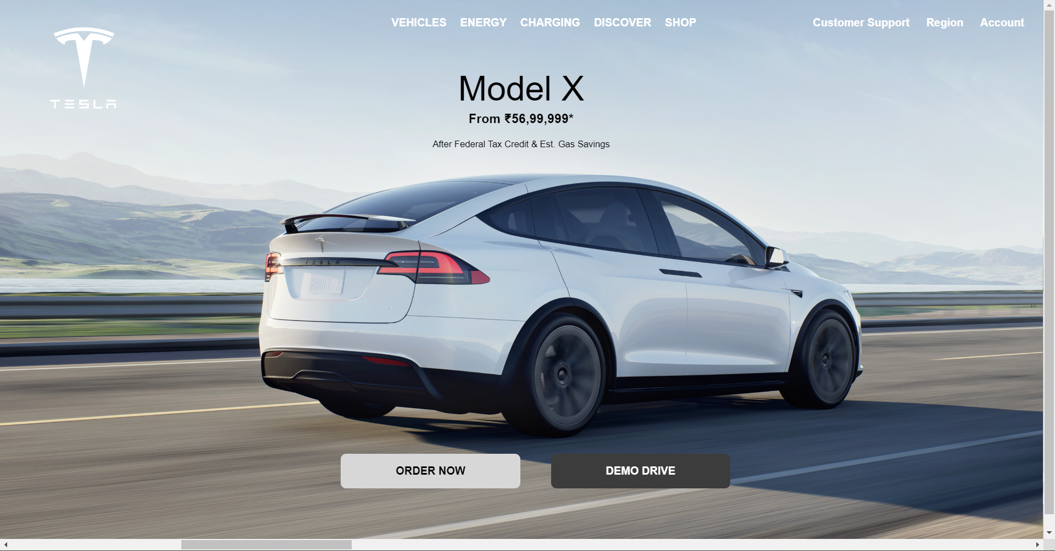

The scrollbar down in the image helps to view others things also that is available in the webpage.



The upper section of website contains various features through which we can explore the website.



Top right corner contains the customer support and account region which helps the customer in right direction.



Top left corner contains the website logo and website address. If we click on it we will be redirected to itself again.

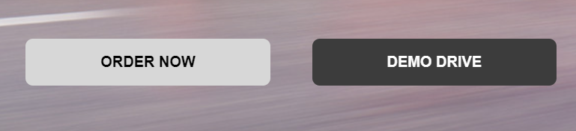

Middle part contains two options which are for further steps towards buying a car.

**UTILITIES AND TECHNOLOGIES USED**

In the project we have used Visual Studio Code for writing code and saving it for future requirements. All directories and files are saved there and we will provide a derive link for the same.

For creating this Website we have used HTML, CSS and web browser.

HTML is used for creating a website. HTML helps in adding images, documents with headings, text, tables, lists, photos, etc. Retrieve online information via hypertext links, at the click of a button. All features button our added using HTML.

CSS is cascading style sheet which is used here for adding design and making it more stylish.

**FUTURE SCOPE AND CONCLUSIONS**

The provided HTML code represents the structure of a web page for a project related to web design and Tesla. It starts with a document type declaration (`<!DOCTYPE html>`) indicating the use of HTML5. The `<html>` element specifies the document's language as English.

In the `<head>` section, various meta tags define the character encoding and viewport settings. The page title is set to "WEB DESIGNING PROJECT," and it links external stylesheets, including Font Awesome icons and a custom stylesheet called "tesla.css." Additionally, a favicon is defined for the web page.

The `<body>` section contains the visible content of the webpage, organized into a header, navigation menu, and main content area. The header includes a logo and navigation links to different sections of the Tesla-related content. The main content area showcases various Tesla models, providing information, images, and videos. The page appears to be designed for presenting and promoting Tesla products and services, with links to external Tesla web pages for further details and actions like ordering and test driving.

The provided CSS code contains styling instructions for various elements on a web page. Here's a summary of the key CSS rules:

1. `*`: This rule selects all elements on the page and sets common properties like removing list-style, setting margin and padding to 0, and defining a sans-serif font with bold text.

2. `body`: Styles applied to the entire page's body include setting the box-sizing model to border-box, which ensures that padding and border sizes don't affect the element's total width. It also hides horizontal overflow and sets a cursor style for the logo.

3. `.logo`: Styling specific to elements with the class "logo," including margin-top and cursor properties.

4. `.btn` and `.btn1`: Styling for buttons, including margin, position, and alignment properties. The `.btn1` class is a sub-class of `.btn` with additional margin settings.

5. `header`: Styles for the header section, which include setting margins, positioning, display, and justifying content between elements. It's set to a fixed position at the top of the page.

6. `header a`: Styles for links within the header, affecting properties like line height, padding, text color, and background on hover. These rules create a visual effect when hovering over links.

7. `.main1` and related elements: Styles for the main content area of the page. `.main1` is a flex container with specific settings for its child divs, videos, and images, ensuring proper display and scrolling behavior.

8. `.main2`: Position settings for individual content sections within the main area.

9. `.head` and `.head1`: Styles for the headings and content within content sections. These rules include positioning, display, font size, and animation properties for text elements.

10. `@keyframes`: Animation definitions for various elements, defining keyframes for animation transitions. These keyframes control the appearance and movement of text elements during animations like showing text and order transitions.

Overall, the CSS code is responsible for the visual appearance and animation effects of the web page, creating a dynamic and engaging user experience.